*"""1) Load all three datasets into separate Dataframes. Keep the Dataframe variable name as summer, winter, country_codes.*



*2) Display a subset of Summer Dataframe with 8 rows (after 6th index) with columns Year, Athlete and Medal  
Expected output:*

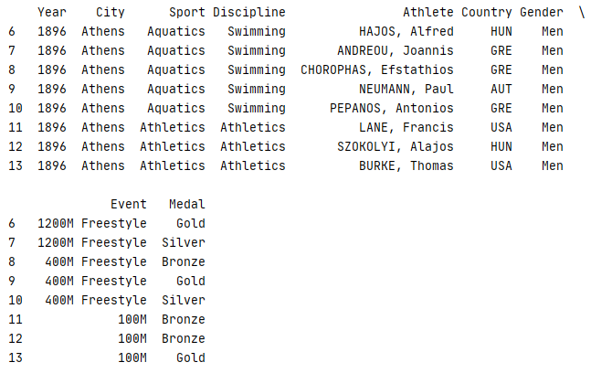

*3) Replace all commas with space in the 'Athlete' column of Summer and winter Dataframe.*

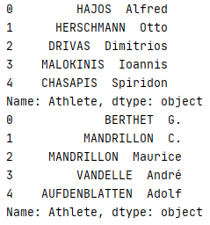

*4) Modify Summer Dataframe by merging Summer Dataframe with country_codes Dataframe based on the country code.*

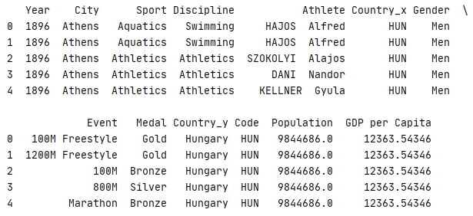

*5) Modify Winter dataframe by merging Winter Dataframe with country_codes Dataframe based on the country code.*

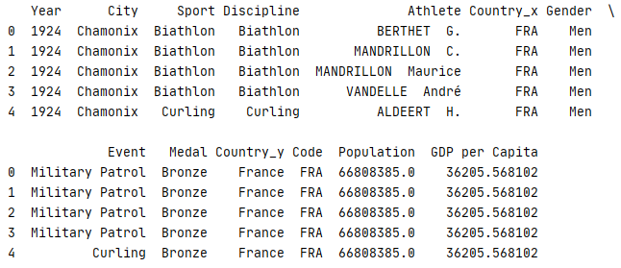

*6) Create a function to find the male athlete & female Athlete who won the highest number of medals.*

*You should pass the Summer/Winter Dataframe object to the function. Also pass the gender to the function.  
 The function should return the name of the male/female athlete who won the highest number of medals.  
 Function Definition:*

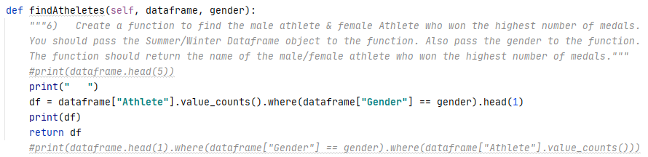

 *7) Create a function to find the athlete who won the highest number of medals in each medal category (Gold, Bronze, Silver).*

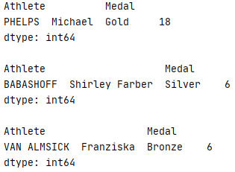 *9) Extract a series with total number of medals won by each country in Summer and Winter.*

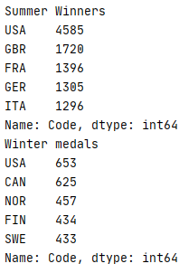 *10) Combine Summer and Winter Olympics data and create a bar chart showing the top 10 highest medal winning countries.  
"""*

